Rebate Overview

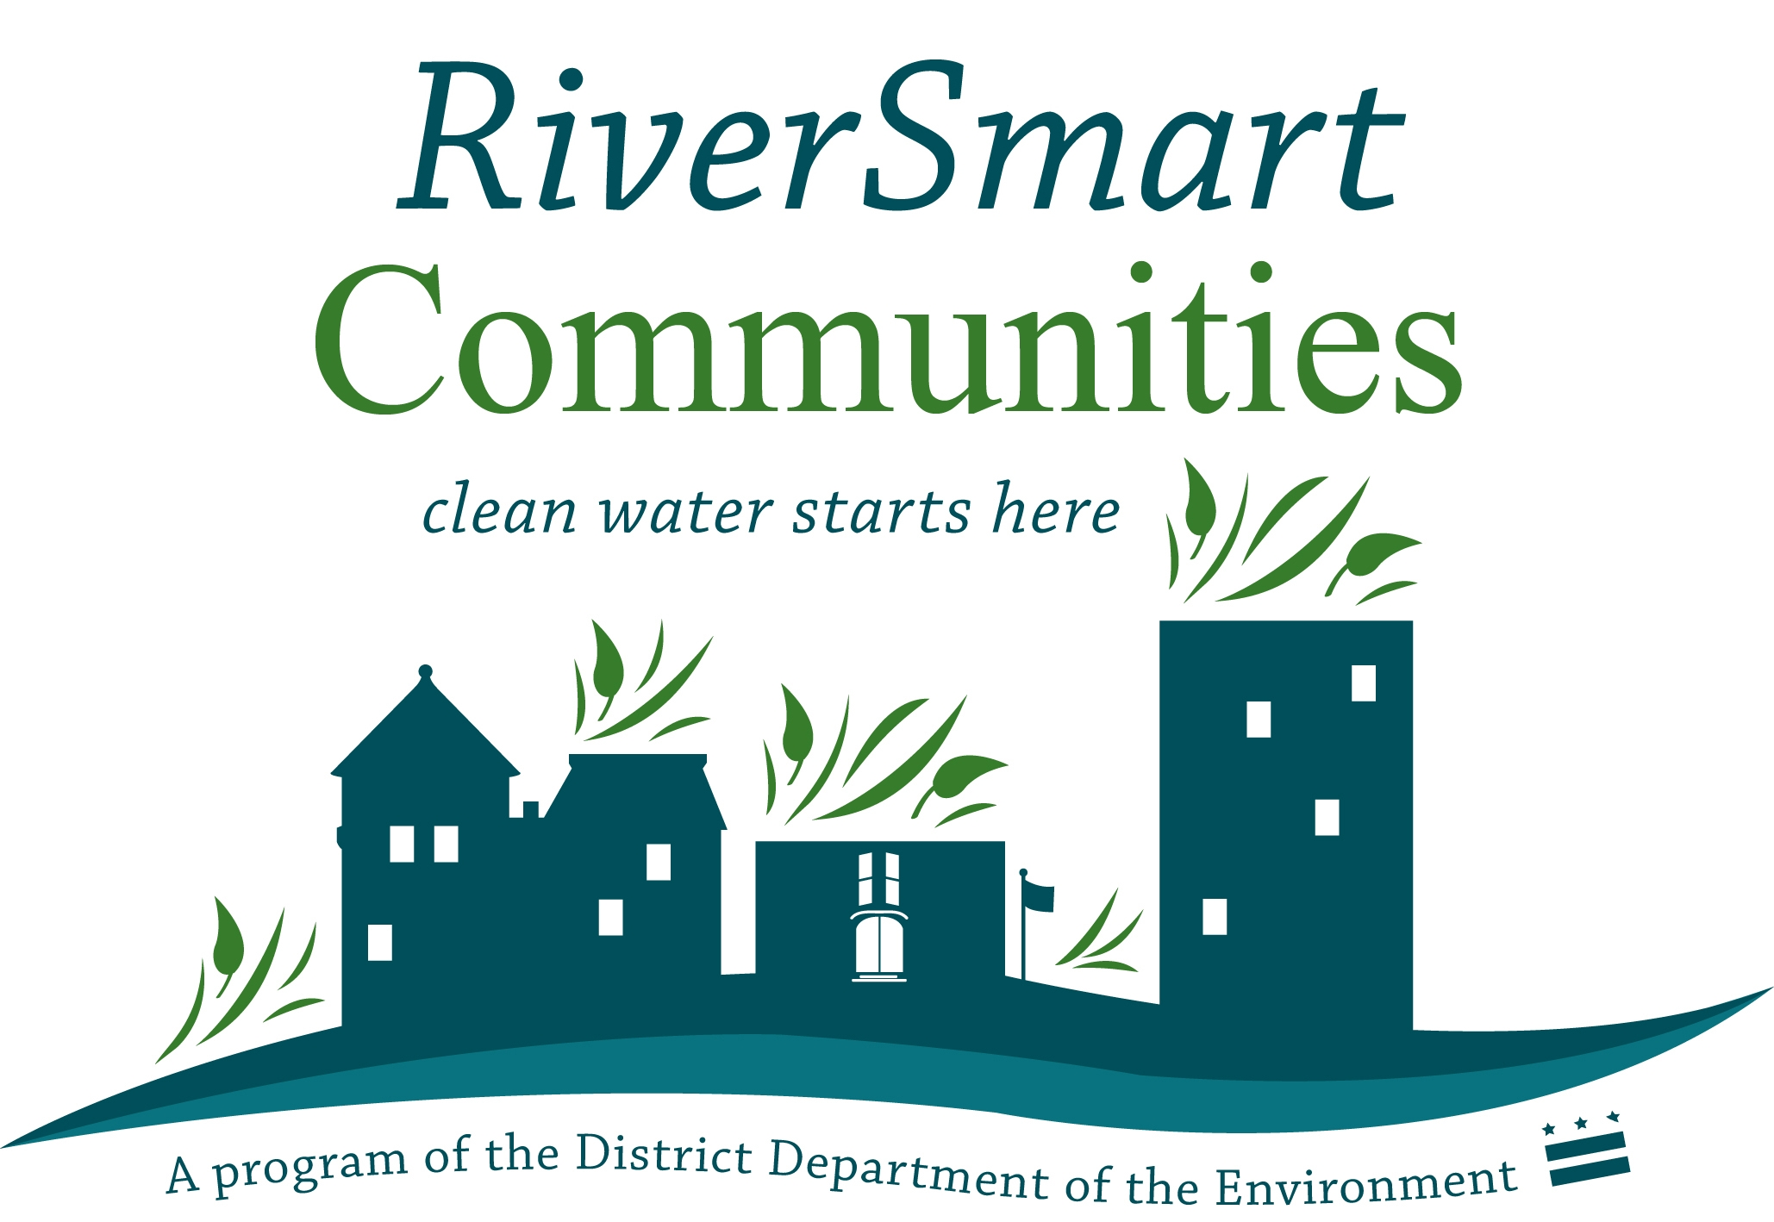

The RiverSmart Communities program offers financial and technical assistance to encourage the use of Low Impact Development such as rain gardens, BayScaping, pervious pavement, and rain cisterns to control nonpoint source pollution on their property. Property owners may apply for a rebate of up to 60% of the project cost for Low Impact Development retrofits. Other stormwater management practices such as vegetated swales and dry wells will be considered on a case by case basis. (Note that BayScaping projects must be combined with a rain garden and/or cistern and BayScapes alone will not be eligible for grant funding.)

Applications will be reviewed on the last Thursday of each month. Awards will be granted based on environmental benefit, cost-effectiveness, and feasibility. Applicants will be notified on the status of your grant within one week of review. The review committee will either grant funding, suggest changes to make the project fit DDOE requirements, or decline. If changes are suggested, you may resubmit the application for the following month’s review meeting.

Grantees will have ninety days to install the LID practice. DDOE and AWS must be informed of construction start date and provided with an installation schedule in advance of five business days before breaking ground. Rebate will be issued after final inspection of installed practice.

Application Process:

- Site audit (optional): A DDOE stormwater auditor can perform an assessment of the property and make recommendations for potential Low Impact Development (LID) projects.
- Choose LID practice(s) to install
- Solicit estimates from contractors
- Submit application with the following supporting documents:
  - Letters of support
  - Design sketch and stormwater calculations
  - Contractor’s proposal and budget
  - Infiltration test results (rain gardens and permeable pavement only)
  - At least 4 photos of current conditions of site location (before photos)
  - Two year maintenance plan

Contact Leah Lemoine, Environmental Protection Specialist (leah.lemoine@dc.gov / (202) 654-6131) or Mary Abe (mabe@anacostiaws.org / (301)699-6204) for more information.

