Sustainable Energy Utility Advisory Board (SEUAB) Meeting
Monday, May 15, 2023
1:00 PM – 3:00 PM

Call to Order
Chair Bicky Corman called the meeting to order at 1:03 PM, May 15, 2023. Chair Bicky Corman called a quorum of the Sustainable Energy Utility Advisory Board (SEUAB or Board) at 1:06 PM. This was a Microsoft Teams video conference call meeting.

Roll Call/Instructions
Roll call was taken at 1:04 PM and the following people were in attendance:

Board Members
Name | In Attendance? | FY 2023  Special Meetings  Attendance Record | FY 2023  Sub Committee Meeting  Attendance Record | FY 2023 Regular Meetings  Attendance Record
Bicky Corman - Board Chair (Mayor’s Designee) | Yes | 6/6 | 1/1 | 6/7
Marshall Duer-Balkind – Vice Chair (Councilmember Allen) | Yes | 6/6 | 1/1 | 7/7
Sandra Mattavous-Frye (or OPC proxy) | Yes | 6/6 | 1/1 | 7/7
Danielle Gurkin (PSC) | Yes | 4/6 | 0/1 | 7/7
Pending -James Pittman (Electric Company) | Yes | 6/6 | 1/1 | 7/7
Eric Jones (Building Management) | Yes | 6/6 | 1/1 | 7/7
Nina Dodge (Environment) | Yes | 5/6 | 0/1 | 7/7
Jamal Lewis (Low-Income Community) | No | 6/6 | 0/1 | 5/7
Vacant (Economic Development) | N/A | N/A | N/A | N/A
Sasha Srivastava (Renewable Energy) | Yes | 6/6 | 1/1 | 7/7
Vacant (Building Construction) | N/A | N/A | N/A | N/A
Vacant (Council Chairperson Mendelson) | N/A | N/A | N/A | N/A
Pending – Portia Hurtt (Gas Utility) | Yes | 1/6 | 0/1 | 3/7

Other Attendees: Sarah Kogel-Smucker (OPC), Ernest Jolly (DCSEU), Patti Boyd (DCSEU), Angela Johnson (DCSEU), Patti Boyd (DCSEU), Tamara Christopher (DCSEU), Ben Burdick (DCSEU), Dr. Lance Loncke (DOEE), Hussain Karim (DOEE), Jennifer Johnston (DOEE), Manny Geraldo (WGL)

Approval of Agenda
- Chair Bicky Corman moved to approve the agenda and was seconded by Vice Chair Marshall Duer-Balkind and Sarah Kogel-Smucker (OPC). All were in favor, and none were opposed.

Approval of April Minutes
- Chair Bicky Corman moved to approve the April meeting minutes and was seconded by Vice Chair Marshall Duer-Balkind. All were in favor, and none were opposed.

FY23 Q2 DCSEU Performance
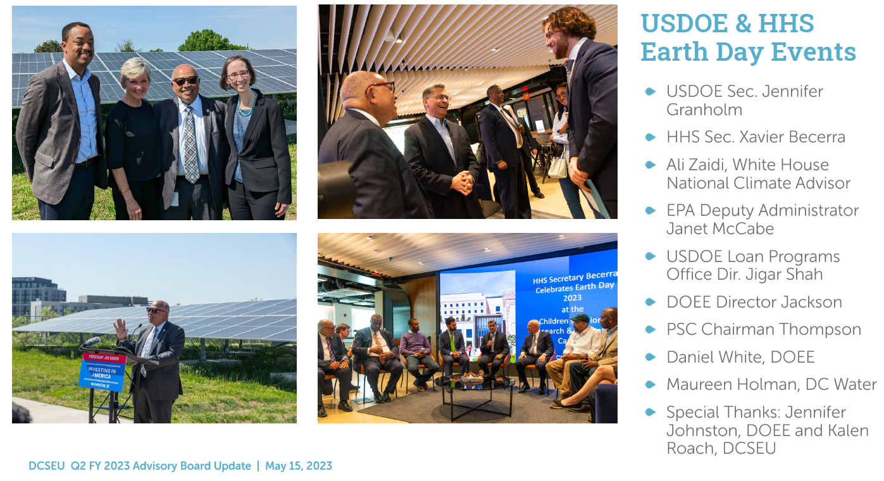
- Chair Bicky Corman asked how the DCSEU became involved with these events?
- Director Ernest Jolly (DCSEU) shared that US DOE and US HHS were interested in highlighting the connection between community solar/health and the Solar for All program was a fit perfectly for what their team were seeking for Earth Day events.
- Nina Dodge inquired whether the US DOE representatives knew that the Solar for All program covered single family roof replacements.
- Director Ernest Jolly (DCSEU) explained that the US DOE event primarily focused on community solar.
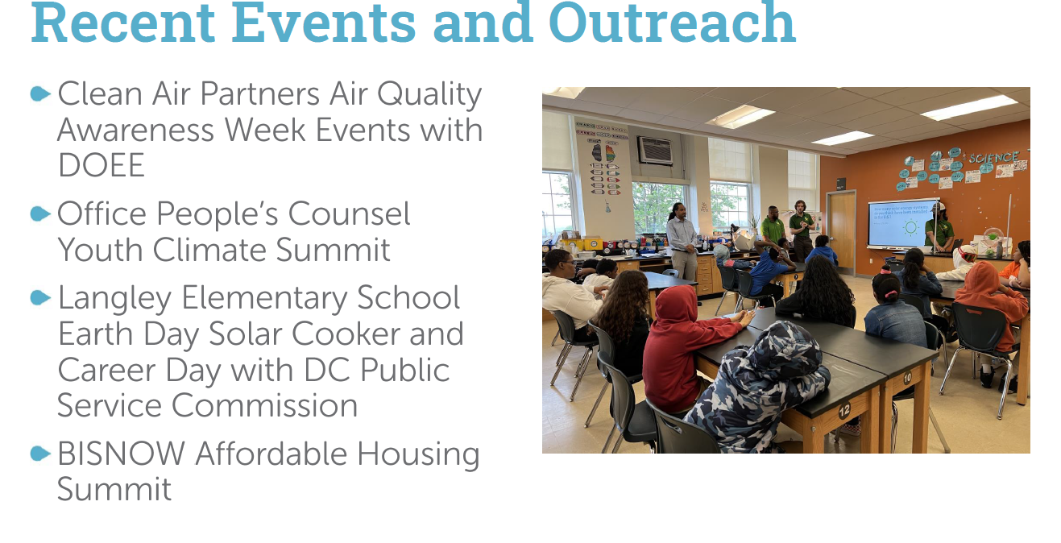
- Ben Burdick (DCSEU) thanked OPC for hosting and inviting DCSEU to its Youth Summit.
- Sarah Kogel-Smucker (OPC) thanked DCSEU, DOEE, Pepco, Sierra Club, and partners for making OPC’s Youth Summit a success.
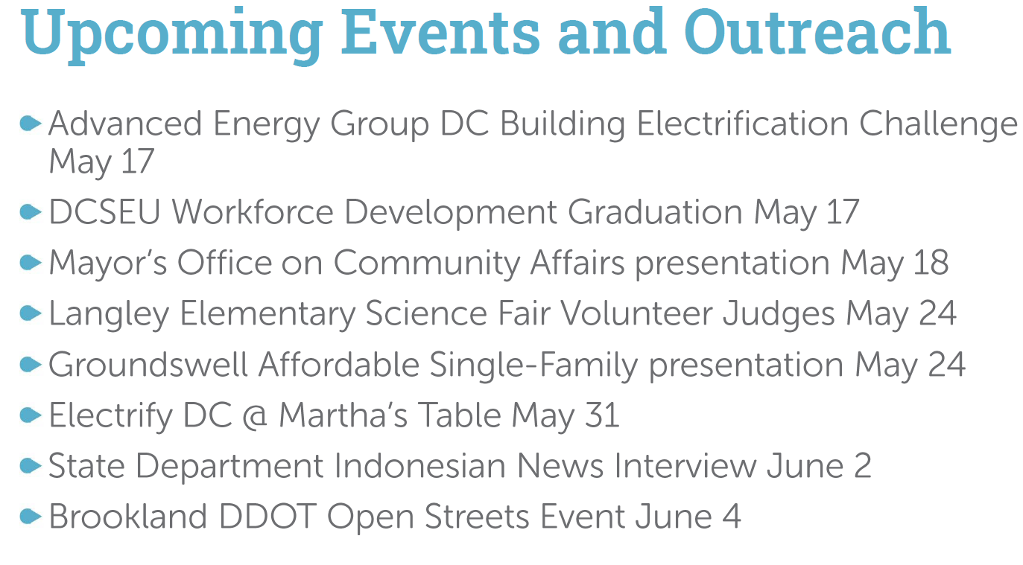
- Ben Burdick (DCSEU) invited Board members to the DCSEU workforce graduation on Wednesday, May 17.
- Ben Burdick (DCSEU) shared that Children’s National compiled a map (based off public data) of all District buildings and connected the instances of children with pulmonary issues (based off Children’s National internal data). He offered to share the map with the Board.
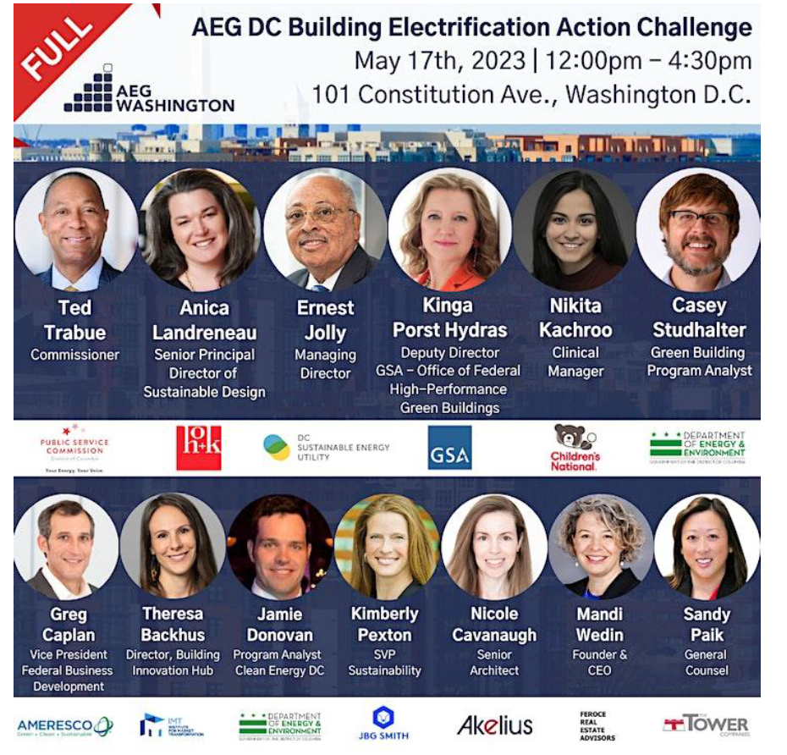
- Chair Bicky Corman highlighted the connection between electrification and indoor air quality and asked if the utilities were exploring this space (health and electrification).
- Sarah Kogel-Smucker (OPC) shared that none of the utility proposals included indoor air quality in their cost benefit analysis.
- Chair Bicky Corman asked if indoor air quality was a measure DCSEU tracked.
- Ben Burdick (DCSEU) confirmed the DCSEU did not track indoor air quality.
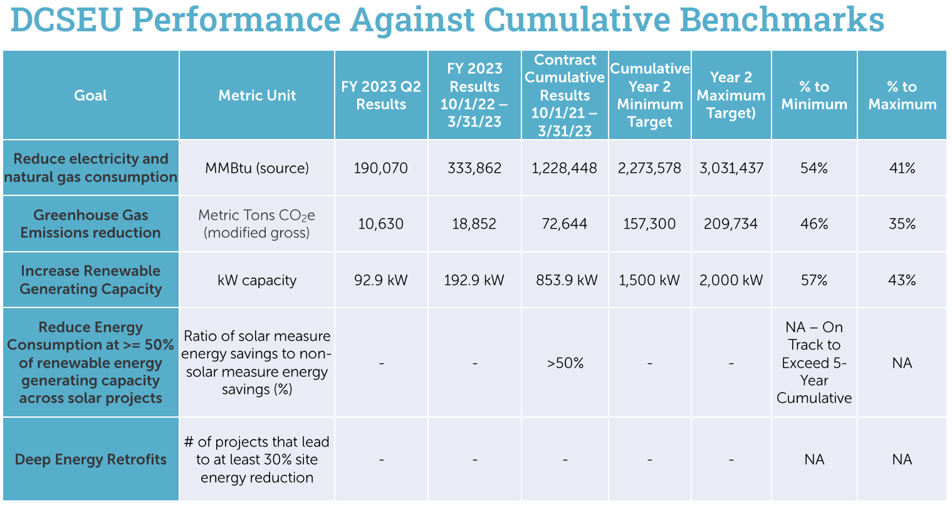
- Nina Dodge asked if the DCSEU could elaborate on the Reduce Energy Consumption at >= 50% of renewable energy generating capacity across solar projects benchmark.
- Patti Boyd (DCSEU) explained the idea behind this goal is that instead of supporting building projects with only renewable energy (ex. just solar panels installed), DCSEU thought to require those buildings (or those building owners) to also incorporate energy efficiency at that building. She also highlighted that these projects are all funded by SETF (Sustainable Energy Trust Fund).
- Nina Dodge inquired how the DCSEU requires energy efficiency through these projects.
- Patti Boyd (DCSEU) mentioned that anytime DCSEU supports a measure, energy efficiency or otherwise, DCSEU does so through an incentive agreement (agreement between DCSEU and building owner/representative). DCSEU will not provide an incentive agreement if the building does not agree to do both things (renewable energy and energy efficiency).
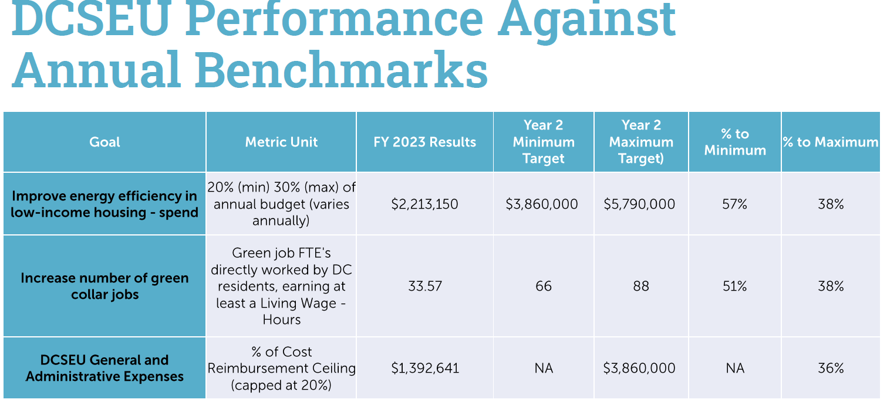
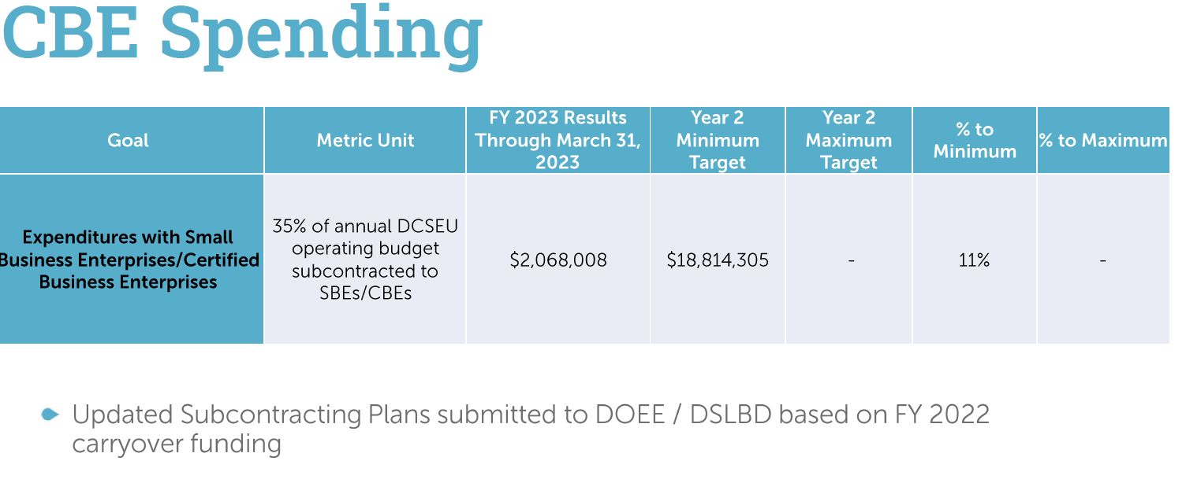
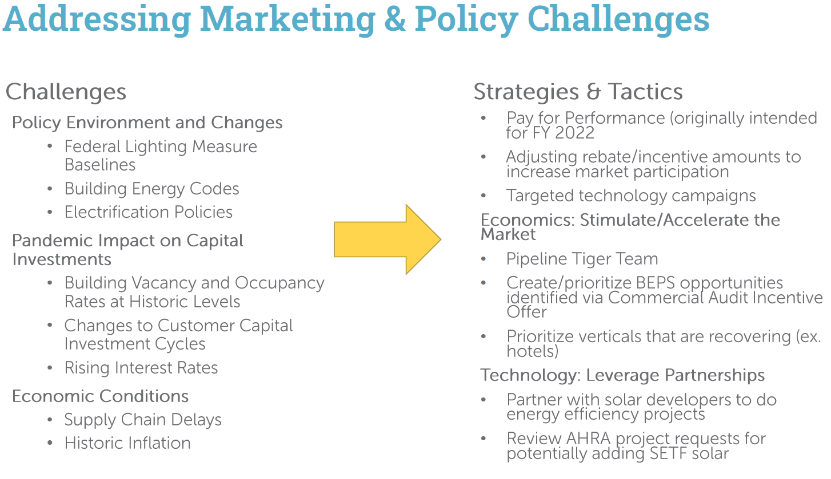
- Chair Bicky Corman asked how pay for performance is an answer to the challenge of increasingly stringent lighting.
- Patti Boyd (DCSEU) shared that pay for performance is a tool that can result in potentially a lot of energy savings because it rewards building owners to operate their buildings more efficiently using building management or operating systems. She also mentioned that energy savings can be calculated for any type of project the building owner does do, but it is the pay for performance that is more tailored for those operational changes.
- Nina Dodge asked what the DCSEU meant by "vertical" markets.
- Ben Burdick (DCSEU) explained that “vertical” market in which vendors offer goods and services specific to an industry, trade, profession, or other group of customers with specialized needs.
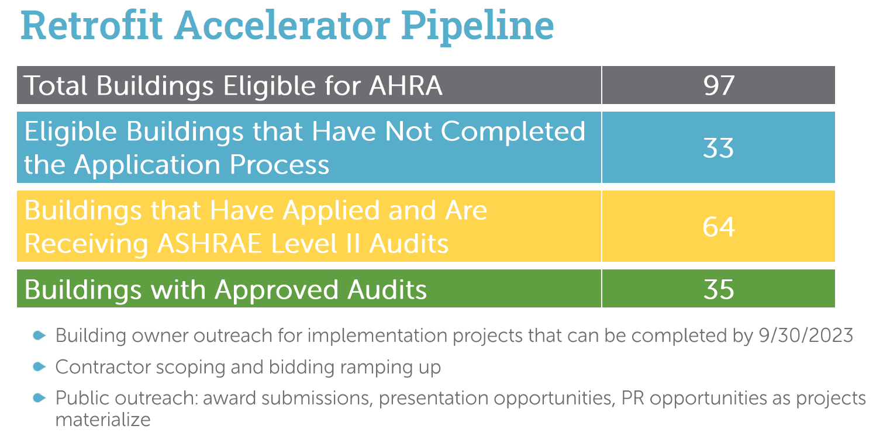

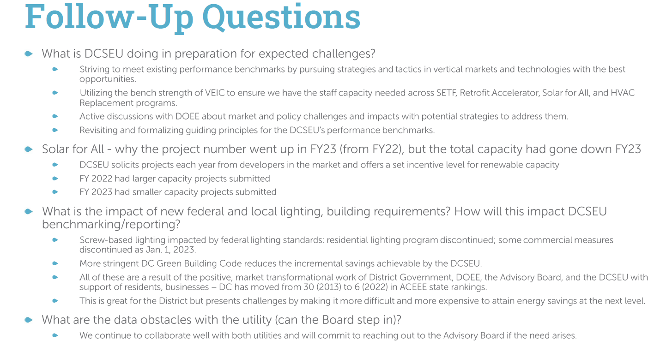
- Vice Chair Marshall Duer-Balkind asked whether AHRA properties included other types of properties outside of affordable housing, like houses of worship or senior care facilities.
- Ben Burdick (DCSEU) shared there are some houses of worship and senior care facilities that are participating in AHRA.
- Nina Dodge asked if any DCSEU programs had an indoor air quality component and also asked if DCSEU addressed lead, mold, paint, ventilation, or any plans to include those components.
- Ernest Jolly and Ben Burdick (DCSEU) shared that these components are not included in DCSEU programs, however any time combustion is taken away, that improves the buildings overall air quality.
- Sarah Kogel-Smucker (OPC) shared that there is not any DC specific data about indoor air quality and the connection between electrification. She asked if the DCSEU was considering partnering with an organization to do a comparative measurement before and after electrification/energy efficiency measures.
- Dr. Lance Loncke (DOEE) shared that the Societal Cost Test incorporates a 5% non-energy benefit related to indoor air quality, but the team could explore this measurement.
- Vice Chair Marshall shared that more research is needed for the connection between electrification and indoor air quality. He also cautioned the group to add an indoor air quality benchmark because indoor air quality measuring is very expensive.
- Sasha Srivastava asked how many District residents are participating in Solar for All.
- Jennifer Johnston provided this information in a follow-up email - 7,023 subscribers overall (471 CREF, 634 single family, and 918 in-kind NEM).
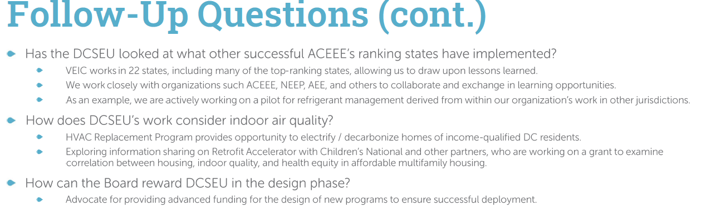

DCSEUAB Annual Report
- Dr. Lance Loncke (DOEE) shared that NMR’s EM&V contract ended this year and DOEE needs to issue a new RFP for the EM&V contract. He explained that for this reason, the Board will not have an EM&V report to review before compiling the Board’s FY22 report.
- Vice Chair Marshall Duer-Balkind and Board members agreed to discuss timeline and assignments during the Board’s June meeting.

DCSEUAB Voting Structure
- Chair Bicky Corman highlighted the difficulty the Board has had convening a quorum with current vacancies and asked if MOTA (Mayor's Office of Talent and Appointments) could provide a timeline on how long it takes for an applicant to become a Board member.

Board Action Items
- Approval of Meeting Agenda
- Approval of April Minutes

Future Agenda Items
- Approval of May Meeting Minutes
- DCSEU FY22 Refresher
- Annual Report Timeline and Assignments
- Tracking bills and legislation
- Indoor air quality and electrification

Adjournment
- Chair Bicky Corman adjourned the meeting at 2:58 PM.

Acronyms used during this meeting
- DCSEU - District of Columbia Sustainability Energy Utility
- DOEE - Department of Energy and Environment
- EEDR – Energy Efficiency and Demand Response
- MOTA – Mayor's Office of Talent and Appointments
- OPC - Office of the People’s Counsel
- PSC - Public Service Commission
- SETF - Sustainable Energy Trust Fund
- WGL – Washington Gas Light
Minutes prepared by Jennifer Johnston, DOEE

