Sustainable Energy Utility Advisory Board (SEUAB) Meeting
Tuesday, September 12, 2023
10:00 AM – 12:00 PM

Call to Order PRESS RECORD
Chair Bicky Corman called the meeting to order at 10:05 AM, September 12, 2023. Chair Bicky Corman called a quorum of the Sustainable Energy Utility Advisory Board (SEUAB or Board) at 10:06 AM. This was a Microsoft Teams video conference call meeting.

Roll Call/Instructions
Roll call was taken at 10:03 AM and the following people were in attendance:

Board Members
Name | In Attendance? | FY 2023  Special Meetings  Attendance Record | FY 2023  Sub Committee Meeting  Attendance Record | FY 2023 Regular Meetings  Attendance Record
Bicky Corman - Board Chair (Mayor’s Designee) | Yes | 6/6 | 1/1 | 8/9
Mansi Talwar (Councilmember Allen) | Yes | 0/0 | 0/0 | 1/1
Sandra Mattavous-Frye (or OPC proxy) | Yes | 6/6 | 1/1 | 9/9
Danielle Gurkin (PSC) | Yes | 4/6 | 0/1 | 9/9
Pending - (Electric Company) | N/A | N/A | N/A | N/A
Eric Jones (Building Management) | Yes | 6/6 | 1/1 | 9/9
Nina Dodge (Environment) | Yes | 5/6 | 0/1 | 9/9
Jamal Lewis (Low-Income Community) | Yes | 6/6 | 0/1 | 7/9
Jaleel Shujath (Economic Development) | No | 0/0 | 0/0 | 1/1
Sasha Srivastava (Renewable Energy) | Yes | 6/6 | 1/1 | 9/9
Giuls Kunkel (Building Construction) | Yes | 0/0 | 0/0 | 2/2
Dr. Larry Martin (Council Chairperson Mendelson) | Yes | 0/0 | 0/0 | 1/1
Pending – Portia Hurtt (Gas Utility) | N/A | N/A | N/A | N/A

Other Attendees: Sarah Kogel-Smucker (OPC), Ernest Jolly (DCSEU), Patti Boyd (DCSEU), Angela Johnson (DCSEU), Crystal McDonald (DCSEU), Solome Girma (DCSEU), Jahmai Sharp (DCSEU), Ben Burdick (DCSEU), Tamara Christopher (DCSEU), Dave Epley (DOEE), Hussain Karim (DOEE), Dr. Lance Loncke (DOEE), Jennifer Johnston (DOEE), Todd Nedwick (National Housing Trust), Poetri Deal (Pepco)

New Board Members
- Chair Bicky Corman welcomed the newest Board members to the meeting, Mansi Talwar, Councilmember Allen’s appointee, and Dr. Larry Martin, Council Chairperson Mendelson’s appointee, who were both sworn in on Monday, September 12th, 2023.
- Mansi Talwar shared that she previously worked for the DCSEU and is now the Executive Director of Engineering, Utilities and Energy at The George Washington University.
- Dr. Larry Martin mentioned that he previously served on the Board when the DCSEU was legislatively established and looks forward to bringing his experience with GRID2.0 to the group.
- Sarah Kogel-Smucker (OPC) shared that the September Board meeting would be her last meeting as a Board member.
- Chair Bicky Corman, Nina Dodge, Dr. Larry Martin, Dave Epley (DOEE), and others thanked Sarah for her service and contributions to the Board and City.
Approval of Agenda
- Chair Bicky Corman moved to approve the agenda and was seconded by Dr. Larry Martin. All were in favor, and none were opposed.

Approval of July Minutes
- Chair Bicky Corman moved to approve the July meeting minutes and was seconded by Eric Jones. Dr. Larry Martin abstained from voting. All were in favor, none were opposed.

DCSEU FY23 Q3 Review
- Ben Burdick (DCSEU) provided DCSEU’s FY23 Q3 updates:
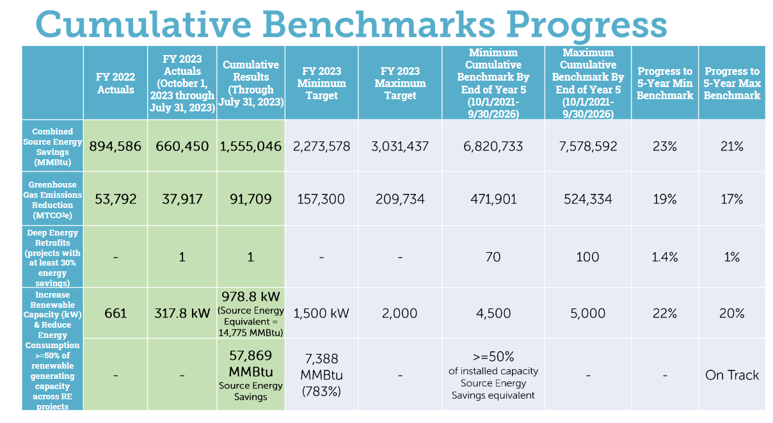
- Chair Bicky Corman mentioned that the DCSEU is now in its second year of the contract, however the numbers look more like what the Board would hope to have seen at the end of year one. She asked where the DCSEU should be (performance wise) to get up to 40% by Q4?
- Ernest Jolly (DCSEU) shared that the DCSEU is looking at modifying its approaches to programs and plans to share that modified approach at a subsequent meeting.
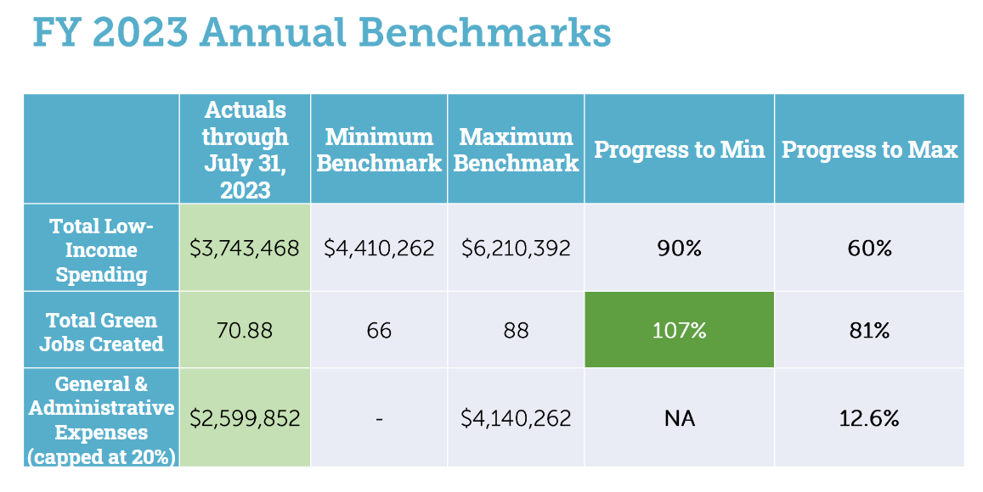
- Nina Dodge asked how many of the FTE’s have a full-time job with full benefits and if that number changed from last year.
- Ben Burdick (DCSEU) shared that the FTE benchmark has not changed from last year where the number of green jobs is be derived from two areas:
  - Hours worked by a District resident at least DC's living wage, OR
  - Every $200,000 in incentive dollars going to customers (every $200,000 counts as one FTE)
- Sarah Kogel-Smucker (OPC) asked what the DCSEU attributed to the reduced (than in years past) low income spend.
- Angela Johnson (DCSEU) shared that in years past the maximum low income spend benchmark was 20% and for the current contract the maximum increased to 30%.
- Ben Burdick (DCSEU) highlighted that the low-income spend benchmark has to balance against energy savings goals which is challenging, however the DCSEU is investing a lot of dollars in affordable multifamily housing through the retrofit accelerator.
- Nina Dodge asked to what extent is the low-income space different from the other sectors.
- Ben Burdick (DCSEU) mentioned that the low-income space is not different from the other sectors in terms of the savings opportunities.
- Patti Boyd (DCSEU) shared that the cost per MW hour is higher for low-income projects than for commercial properties.
- Dr. Lance Loncke (DOEE) clarified that the retrofit accelerator is separate funding from the low-income spend benchmark, where the accelerator is funded through American Rescue Plan (ARPA) which comes from the Sustainable Energy Trust Fund (SETF). He also shared that the low-income spend benchmark was raised from 20% to 30% with the removal of the energy savings requirement upon the request of the DCSEU.
- Dr. Larry Martin highlighted that the competition between performance metrics is not new to the DCSEU, however, it complicates the DCSEU’s mission to balance the success of one metric against another.
- Sarah Kogel-Smucker (OPC) shared that it would be useful for the Advisory Board to understand what the DCSEU’s strategy and approach is to work with the competing metrics.
- Dr. Lance Loncke (DOEE) highlighted the DCSEU’s low-income spend has gone down in part from the Income Qualified Efficiency Fund (IQEF). IQEF is a partnership with low-income multifamily buildings that require building owners to contribute a percentage of the cost towards the projects. These projects are becoming harder to find.
- Eric Jones highlighted that there are many factors the DCSEU must take into consideration and there are a finite number of resources and buildings.
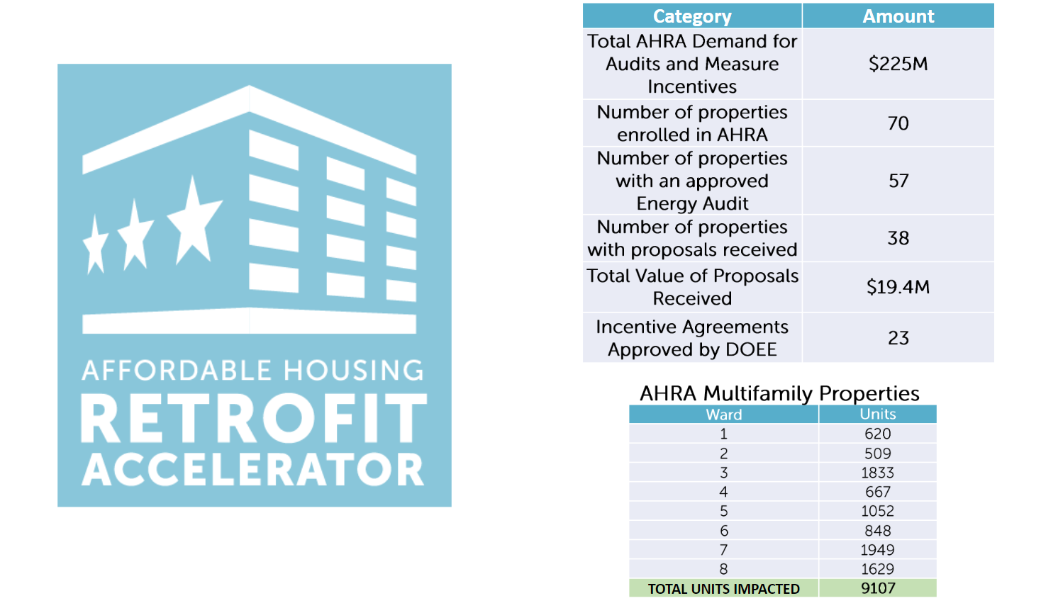
- Chair Bicky Corman asked if the accelerator achievements could be counted towards the DCSEU performance benchmarks.
- Ben Burdick (DCSEU) confirmed that the accelerator achievements could be counted towards the deep energy retrofit and the GHG benchmarks.
- Nina Dodge asked if the low-income spend benchmark was mostly multifamily and if the accelerator could be counted toward the 30% low-income spend benchmark.
- Ben Burdick (DCSEU) shared that the accelerator could not be counted toward the low-income spend since the low-income spend is from the SETF goals, however, most of the properties in the low-income spend are multifamily.
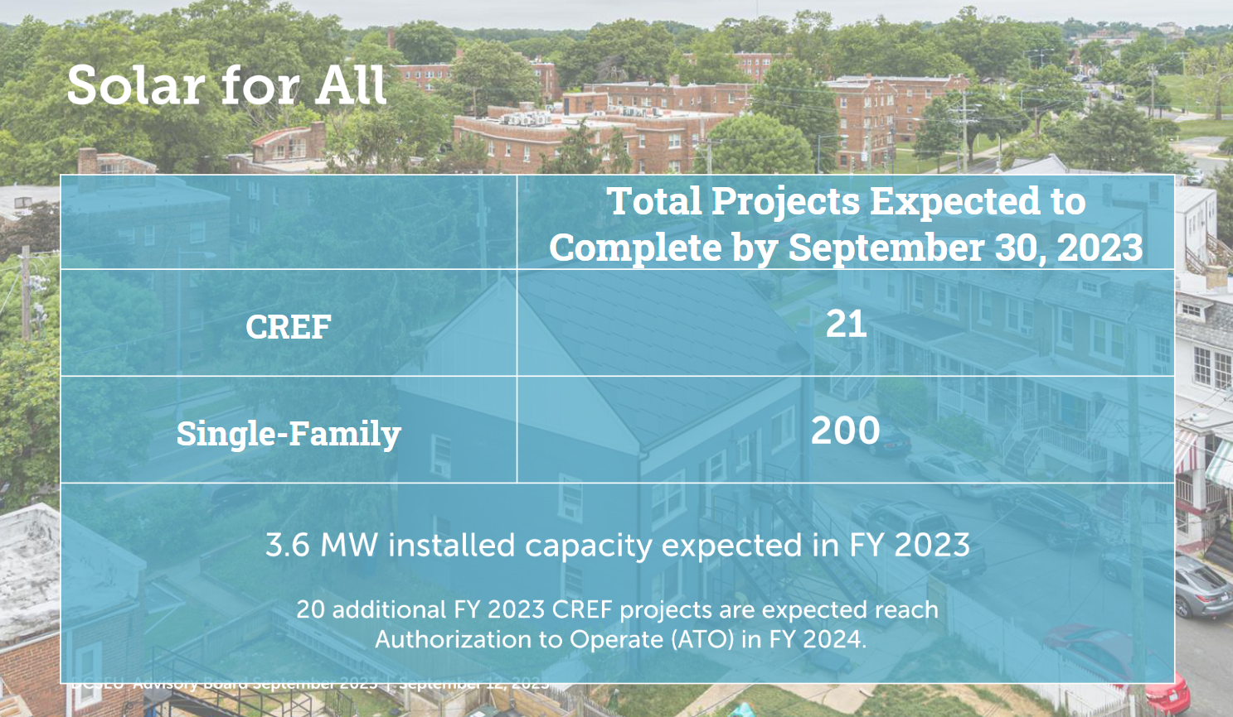

- Dr. Larry Martin asked how much of the DCSEU’s budget was dedicated to Solar for All funding.
- Angela Johnson (DCSEU) shared that the Solar for All program has a budget of $12,150,984.59, the accelerator has a budget of $35,195,136.17, and the base contract is $20,000,000.
- Nina Dodge asked if next time the DCSEU team could provide the number of beneficiaries equivalent to the CREF total and if there was a lag between the authorization to operate and the beginning of the benefits to the beneficiaries.
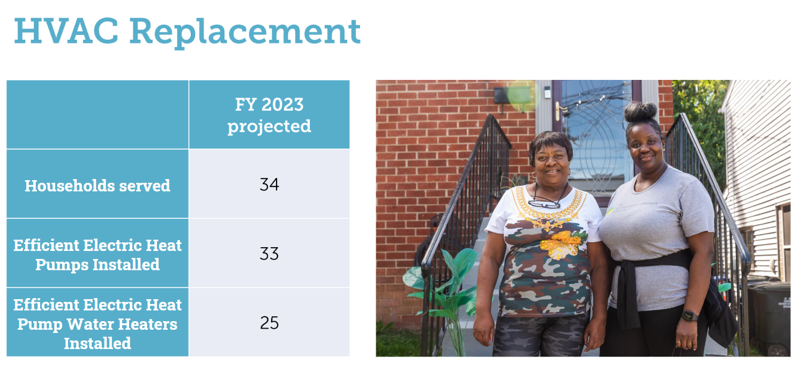
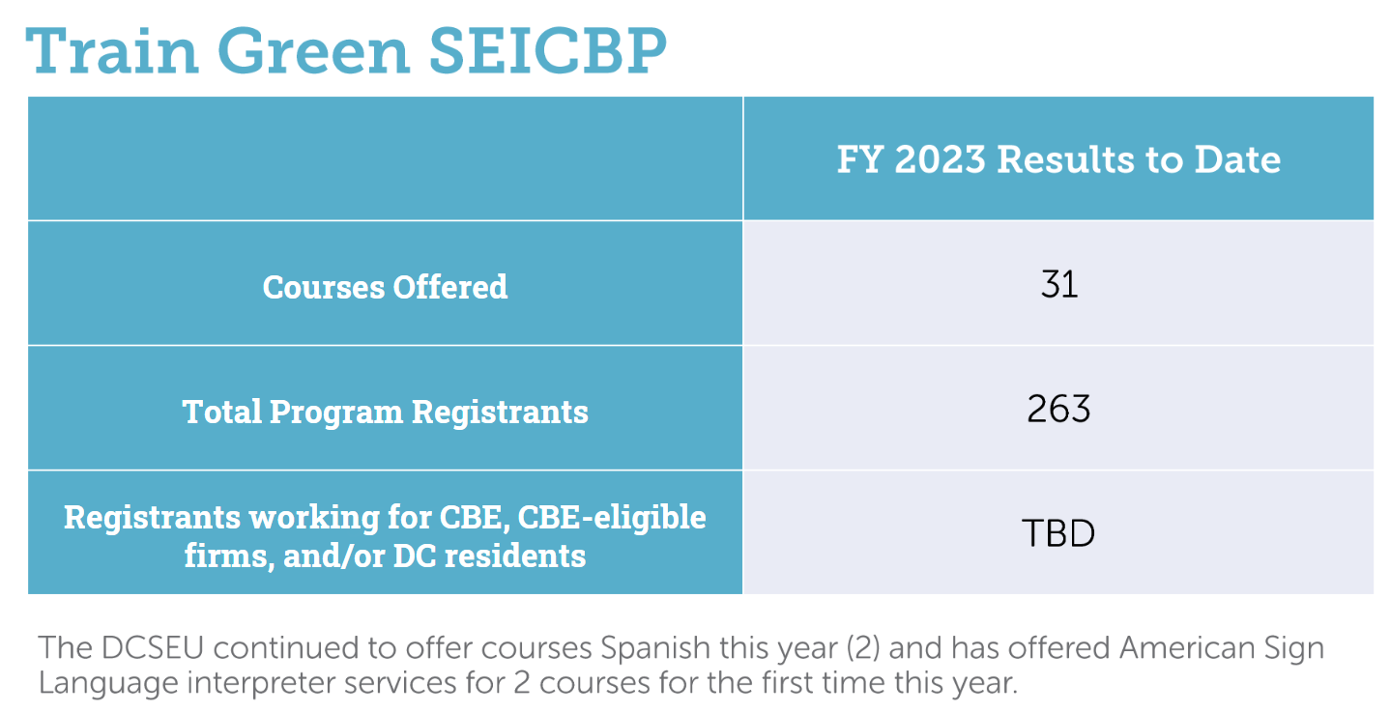
DCSEU Indoor Air Quality
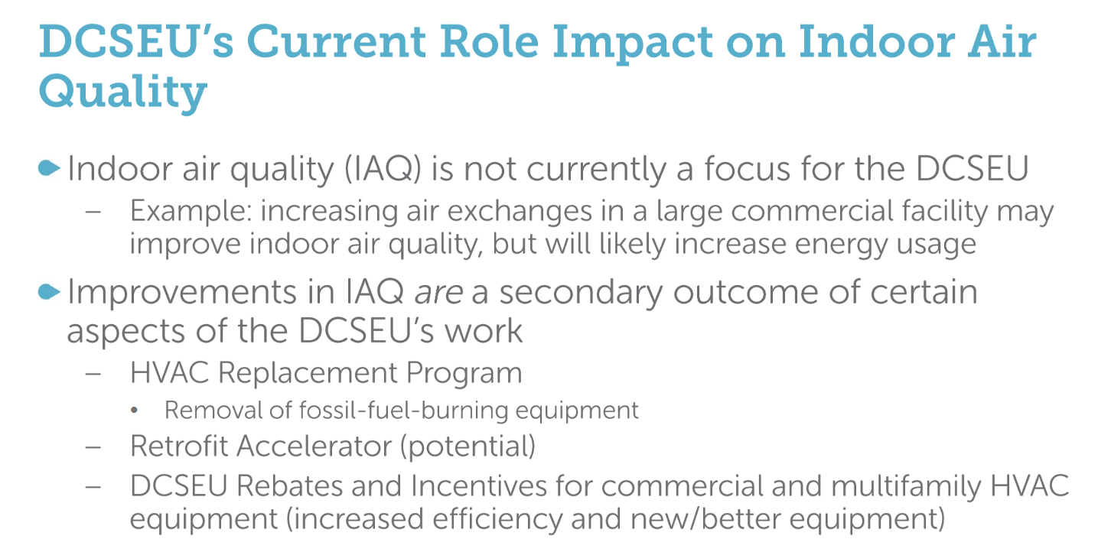
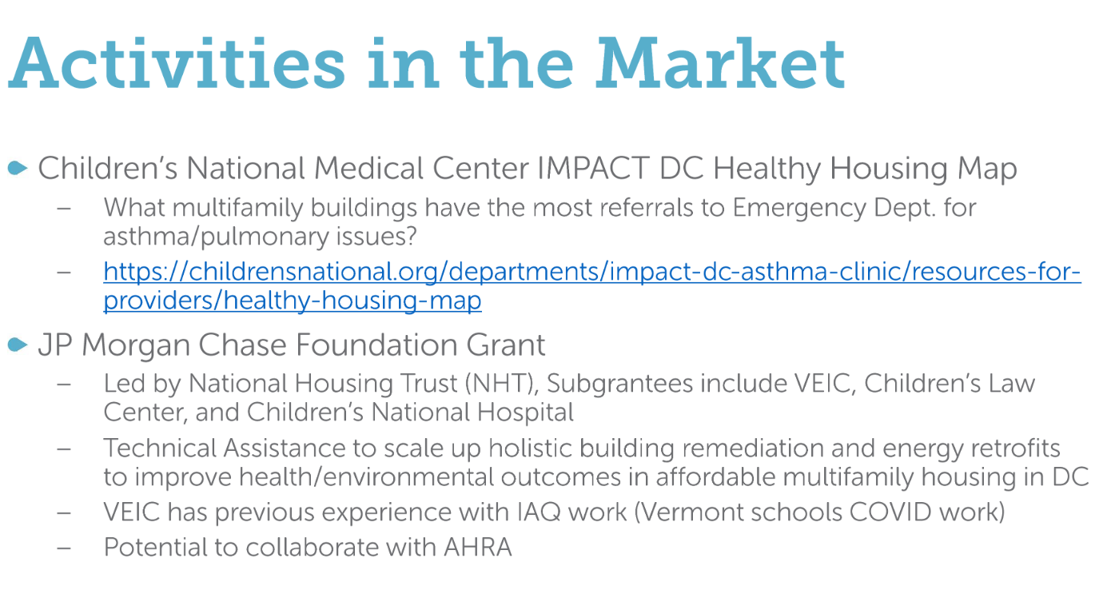

FY24 Annual Plan
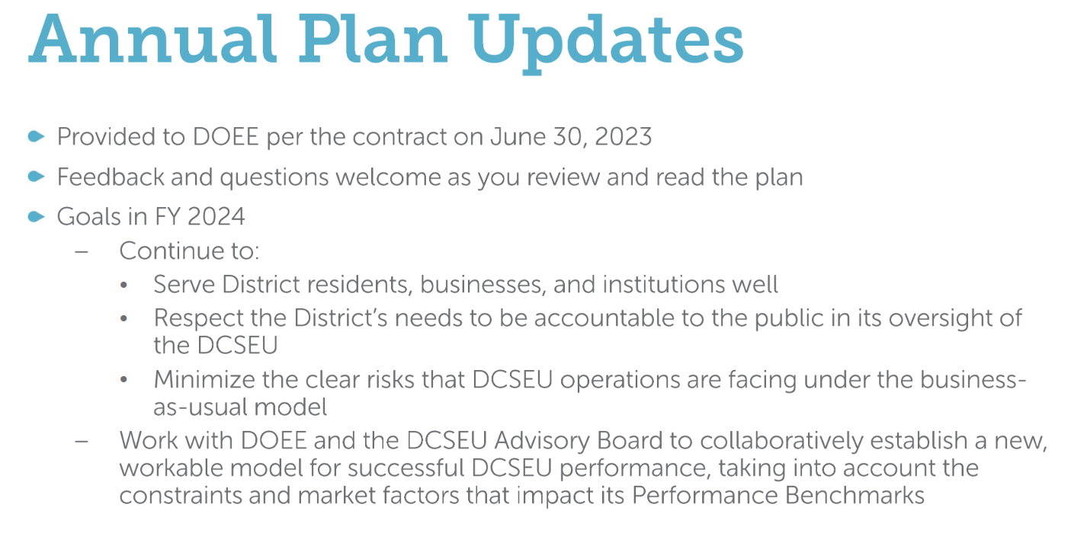
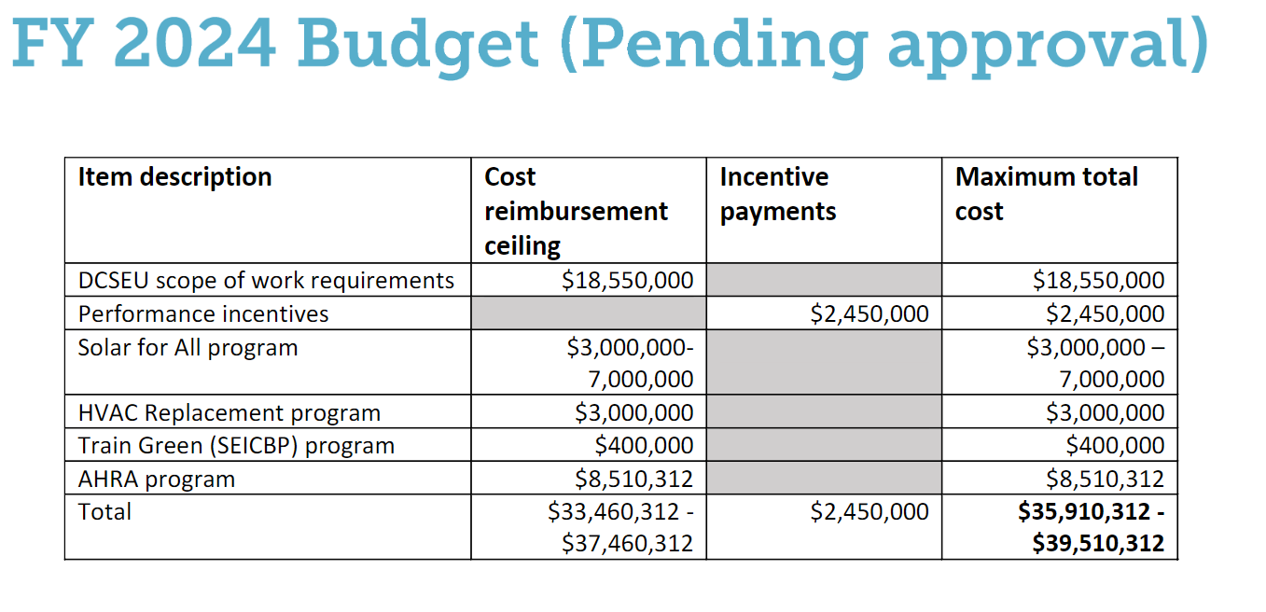
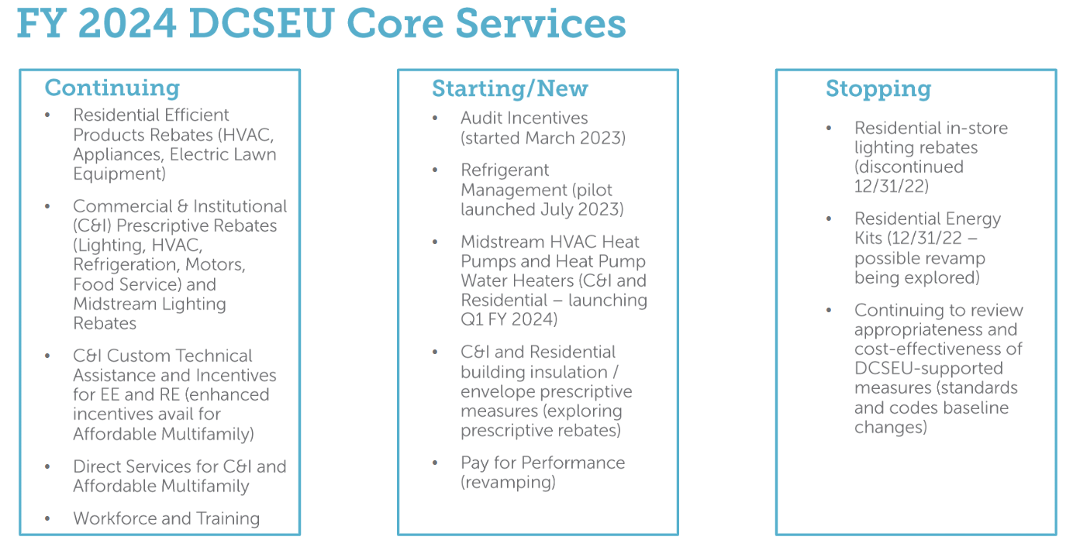
- Dr. Lance Loncke (DOEE) highlighted that although the annual plan was due to DOEE on June 30th, the annual plan is a living document and open to feedback from the Board at any time.
- Chair Bicky Corman noticed that the DCSEU doesn't have a performance benchmark or contract requirement for financial leveraging and asked if that was something the DCSEU was interested in.
- Ben Burdick (DCSEU) mentioned that the DCSEU used to have a financial leveraging requirement of $5 million in the previous contract, however the DCSEU does not have a leveraging benchmark in the current contract. The DCSEU is constantly looking for opportunities for other funding streams whether that is working with the DC Green Bank or seeking grants and foundation funding.
- Nina Dodge requested a separate meeting to discuss the annual plan and problems identified earlier in the meeting.
- Chair Bicky Corman shared that Nina’s suggestion would be revisited once the Board received more information.

DCSEU Benchmark Review
- Dr. Lance Loncke (DOEE) provided a summary of the DCSEU’s request to adjust its benchmarks:
  - Reduce Electricity and Natural Gas Consumption (MMBtu source)
    - The DCSEU is requesting to remove this benchmark from the contract.
  - Green House Gas Emissions Reduction (Metric Tons C0₂e)
    - The DCSEU is requesting to adjust the min and max value.
  - Deep Energy Retrofits (# of projects that lead to at least 30% site energy reduction in 70-100 BEPS buildings)
    - The DCSEU is requesting to change to requirements of this benchmark to # of projects that lead to at least 20% site energy reduction in 40-60 buildings.
- Dr. Larry Martin asked the group what the DCSEU is measuring when considering energy efficiency and energy reductions versus GHG reductions. Dr. Martin explained that he could imagine a scenario whereas a result of PJM's changes, we might not be seeing a whole lot of energy efficiency improvements, but there could be GHG reduction. Dr. Martin asked if DOEE was taking this thinking into account when considering adjusting the benchmarks.
- Dr. Lance Loncke (DOEE) shared that if PJM increased the grid to 100% clean energy, the District still has to address the GHG that are combusting on site, especially for those homes and buildings that are still using natural gas.
- Chair Bicky Corman asked if the DCSEU is not competing deep energy retrofits, then who is.
- Dr. Lance Loncke (DOEE) mentioned that the closest program to a deep energy retrofit is done through Pepco’s program. The money that came through the settlement with Pepco resulted in ICAST managing one of the programs which was trying to get to 20% energy reduction in the building. Dr. Loncke also mentioned that the ICAST contract is closed, and he believed projects were set to be completed by the end of the year.
- Chair Bicky Corman requested a summary of the benchmark changes be distributed to the Board and for an hour be dedicated to this topic for October’s Board meeting.

EM&V Report
- Dr. Lance Loncke (DOEE) shared that DOEE is hoping to get procurement out the door for the EM&V contract by next month. Dr. Loncke shared that for the last couple of years DOEE has been spending about $800,000 for the consultants to verify the DCSEU savings primarily for DOEE to pay DCSEU performance incentives for meeting the benchmarks. Dr. Loncke mentioned that since the DCSEU is lacking in performance, the EM&V report is not going to provide anything substantially different from the numbers provided from the DCSEU.
- Chair Bicky Corman recalled that the EM&V report provided information that the DCSEU did not track, such as acquisition costs or avoided costs.
- Dr. Lance Loncke (DOEE) shared that the acquisition costs can be calculated, however, the acquisition costs will be higher than in FY21 because while the savings have been low, the DCSEU has continued to spend the entire budget.
- Nina Dodge shared that it would be helpful to know where the DCSEU stands in terms of acquisition cost in relation to other energy efficiency programs operated by VEIC and if other organizations are facing similar challenges.

DCSEUAB FY22 Annual Report
- Dr. Larry Martin shared that he would be happy to take the lead on Looking Forward section of the report and would share with the Board within the next two weeks (by September 26, 2023).
- Chair Bicky Corman asked Jennifer Johnston (DOEE) to distribute an updated draft of the annual report, including the executive summary to the Board.

FC1160 - EEDR Programs
- Patti Boyd (DCSEU) summarized DCSEU’s comments on FC1160 and highlighted that the DCSEU did not believe that WGL’s potential study was completely indicative of the potential for energy efficiency in the District.
- Sarah Kogel-Smucker (OPC) summarized DCSEU’s comments on FC1160 and mentioned OPC’s primary concern was that the utilities are operating in a vacuum independent of one another while the energy efficiency potential for gas and electric efficiency is inextricably linked, requiring integrated planning.
- Sarah Kogel-Smucker (OPC) also mentioned that Sierra Club, represented by Earthjustice, is in a discovery dispute with WGL in FC1160. WGL has claimed that the comment period on its application for EEDR has passed with no party including OPC. WGL claims the comment period which was set in a 2019 order. Sarah Kogel-Smucker (OPC) shared that the PSC has not provided guidance on the dispute, however comments can be filed on WGL’s EEDR programs and the OPC plans to file comments.
- Jamal Lewis shared that Rewiring America submitted comments on both Pepco’s and WGL’s potential studies. Jamal highlighted that due to the calculations of averages, Rewiring America believes that both studies underestimate the impact that energy efficiency can have. Rewiring America also requested some clarifications because it was not clear how certain conclusions were derived from the utility’s methods.
- Chair Bicky Corman requested the PSC provide guidance on when the Board should provide comments.

Legislative Updates
- Hussain Karim (DOEE) shared that Pepco’s multiyear rate plan proceeding is ongoing with several climate provisions. Hussain also mentioned that on September 21, 2023, there will be a hearing for Department of Energy and Environment Richard Jackson Confirmation Resolution of 2023.

Board Action Items
- Approval of Meeting Agenda
- Approval of July Minutes

Future Agenda Items
- Approval of September Meeting Minutes
- DCSEU Performance Benchmarks
- Board’s FY22 Annual Report
- DCSEU 2024 Annual Plan
- Discussion of Board providing comments on WGL’s EEDR application and/or Pepco’s Climate Plan

Adjournment
- Chair Bicky Corman adjourned the meeting at 12:02 PM.

Acronyms used during this meeting
- ATO - Authorization to Operate
- CREF - Clean Renewable Energy Facility
- DCSEU - District of Columbia Sustainability Energy Utility
- DOEE - Department of Energy and Environment
- EEDR – Energy Efficiency and Demand Response
- MOTA – Mayor's Office of Talent and Appointments
- OPC - Office of the People’s Counsel
- PSC - Public Service Commission
- SETF - Sustainable Energy Trust Fund
- WGL – Washington Gas Light
Minutes prepared by Jennifer Johnston, DOEE

