Sustainable Energy Utility Advisory Board (SEUAB) Meeting
Tuesday, December 12, 2023
10:00 AM – 12:00 PM

Call to Order
Vice Chair Dr. Larry Martin called the meeting to order at 10:06 AM, December 12, 2023. Dr. Martin called a quorum of the Sustainable Energy Utility Advisory Board (SEUAB or Board) at 10:07 AM. This was a Microsoft Teams video conference call meeting.

Roll Call/Instructions
Roll call was taken at 10:04 AM and the following people were in attendance:

Board Members
Name | In Attendance? | FY 2024 Special Meetings  Attendance Record | FY 2024 Regular Meetings  Attendance Record
Bicky Corman - Board Chair (Mayor’s Designee) | No | 1/1 | 2/2
Mansi Talwar (Councilmember Allen) | Yes | 1/1 | 2/2
Sandra Mattavous-Frye (or OPC proxy) | Yes | 1/1 | 2/2
Danielle Gurkin (PSC) | No | 0/0 | 1/1
Pending - (Electric Company) | N/A | N/A | N/A
Eric Jones (Building Management) | Yes | 0/0 | 3/3
Nina Dodge (Environment) | Yes | 1/1 | 3/3
Jamal Lewis (Low-Income Community) | Yes | 1/1 | 2/2
Jaleel Shujath (Economic Development) | Yes | 1/1 | 3/3
Sasha Srivastava (Renewable Energy) | Yes | 1/1 | 3/3
Giuls Kunkel (Building Construction) | Yes | 1/1 | 1/1
Dr. Larry Martin – Vice Chair (Council Chairperson Mendelson) | Yes | 1/1 | 3/3
Pending – (Gas Utility) | N/A | N/A | N/A

Other Attendees: Patti Boyd (DCSEU), Angela Johnson (DCSEU), Ben Burdick (DCSEU), Crystal McDonald (DCSEU), Jahmai Sharp (DCSEU), Tamara Christopher (DCSEU), Rebecca Foster (VEIC), Jennifer Johnston (DOEE), Dr. Yohannes Mariam (OPC), Kintéshia Scott (OPC), Portia Hurtt (WGL), Poetri Deal (Pepco)

Approval of Agenda
- Vice Chair Dr. Larry Martin moved to approve the agenda and was seconded by Sasha Srivastava. All were in favor, and none were opposed.

Approval of November Minutes
- Vice Chair Dr. Larry Martin moved to approve the November meeting minutes and was seconded by Kintéshia Scott (OPC). All were in favor, none were opposed.

Overview of OPC’s Memo on Societal Cost Test
- Kintéshia Scott (OPC) provided a summary of OPC’s memo on DCSEU’s societal cost test. Main takeaways:
  - Would be beneficial for the DCSEU to include several non-energy benefits adders which could include metrics on energy equity, social equity, racial equity, and environmental justice.
  - An equity adder would be a way to standardize the experiences or provide some type of insight into the actual benefit that low-income consumers might experience.
- Dr. Yohannes Mariam (OPC) elaborated that to the extent he has seen, he is uncertain whether DCSEU’s societal cost test captures equity issues so there is room to include those parameters.
- Kintéshia Scott (OPC) highlighted a few charts in the memo:
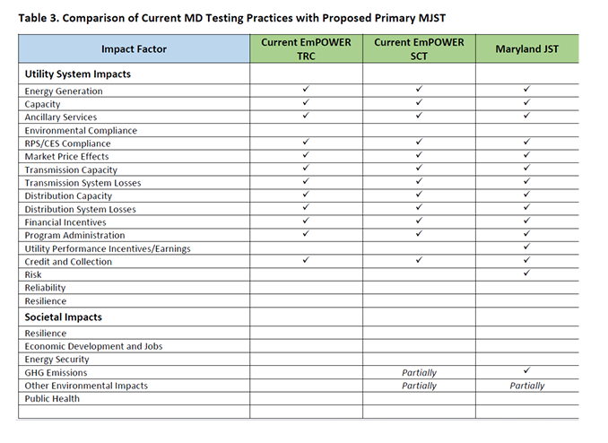

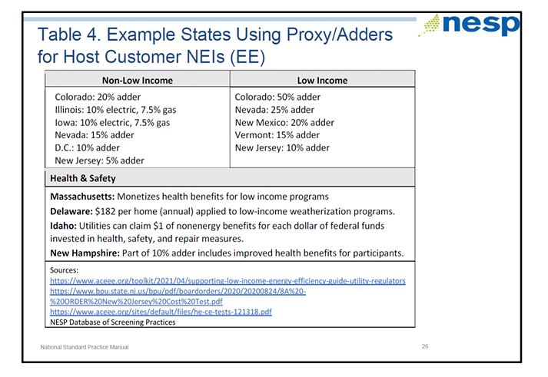
- Vice Chair Dr. Larry Martin sought clarification that the purpose of an adder would be to level up cost-effectiveness for low-income programs that might otherwise be less competitive with other DCSEU investments and allow the DCSEU to appropriately measure their impact. Dr. Martin asked DOEE:
  - DCSEU’s goal is to spend 20-30% of the budget on low-to-moderate income projects and the adders are going to help create the evaluation metric that will ensure DCSEU is not penalized for low-income spending because they may be less cost-effective than other investments, is this correct?
- Vice Chair Dr. Larry Martin shared a recent Public Service Commission (PSC) order on the Benefit Cost Analysis (BCA) Framework which directly relates to the Board's conversation on societal cost test. He observed that the DCSEU’s leadership in this space is influential for how the PSC is thinking about using BCA to evaluate utility investments in DER as well as more traditional infrastructure such as substations and feeders. In several places, DCSEU’s societal cost test is referenced:
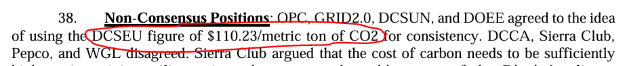
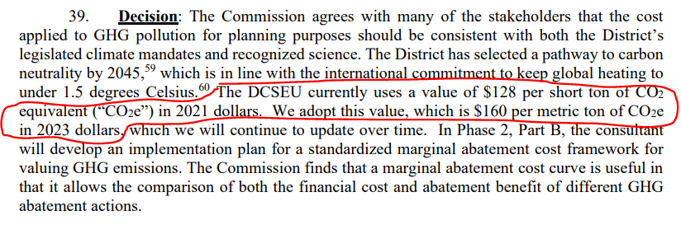

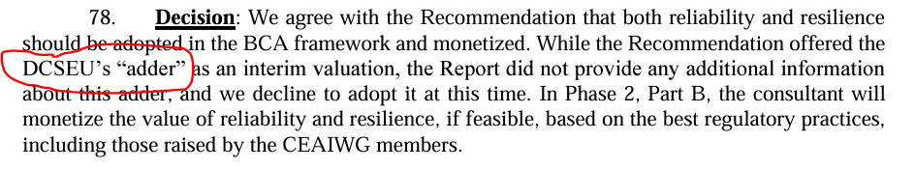

FC1130: Discussion of Board Providing Comments on Synapse’s VDER Study
- Vice Chair Dr. Larry Martin provided a brief presentation on the key findings from the study, highlighting some conclusion he thought to be relevant to the DCSEU’s programs.

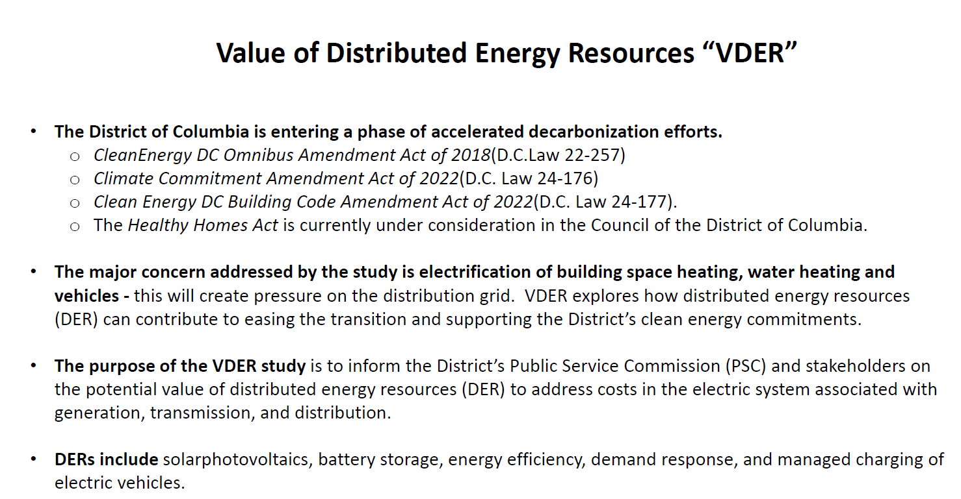
- Jamal Lewis inquired whether geothermal was included under DERs.
- Vice Chair Dr. Larry Martin shared that geothermal may be categorized under energy efficiency.
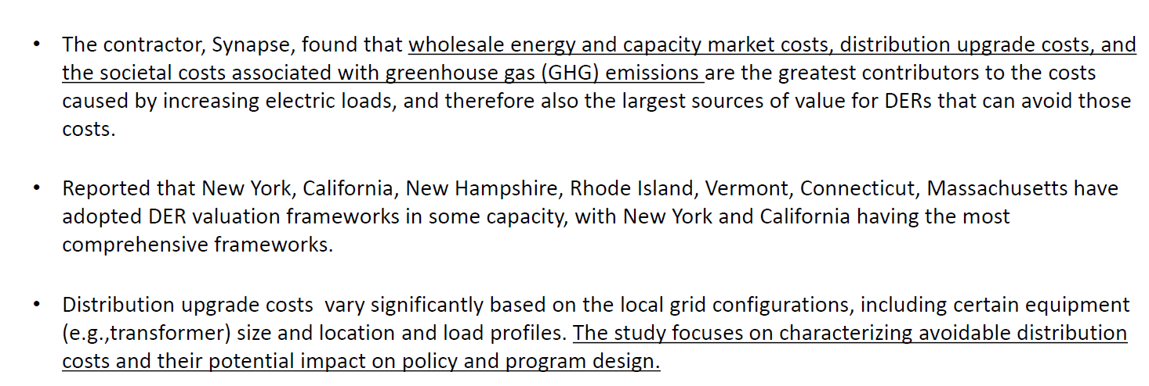
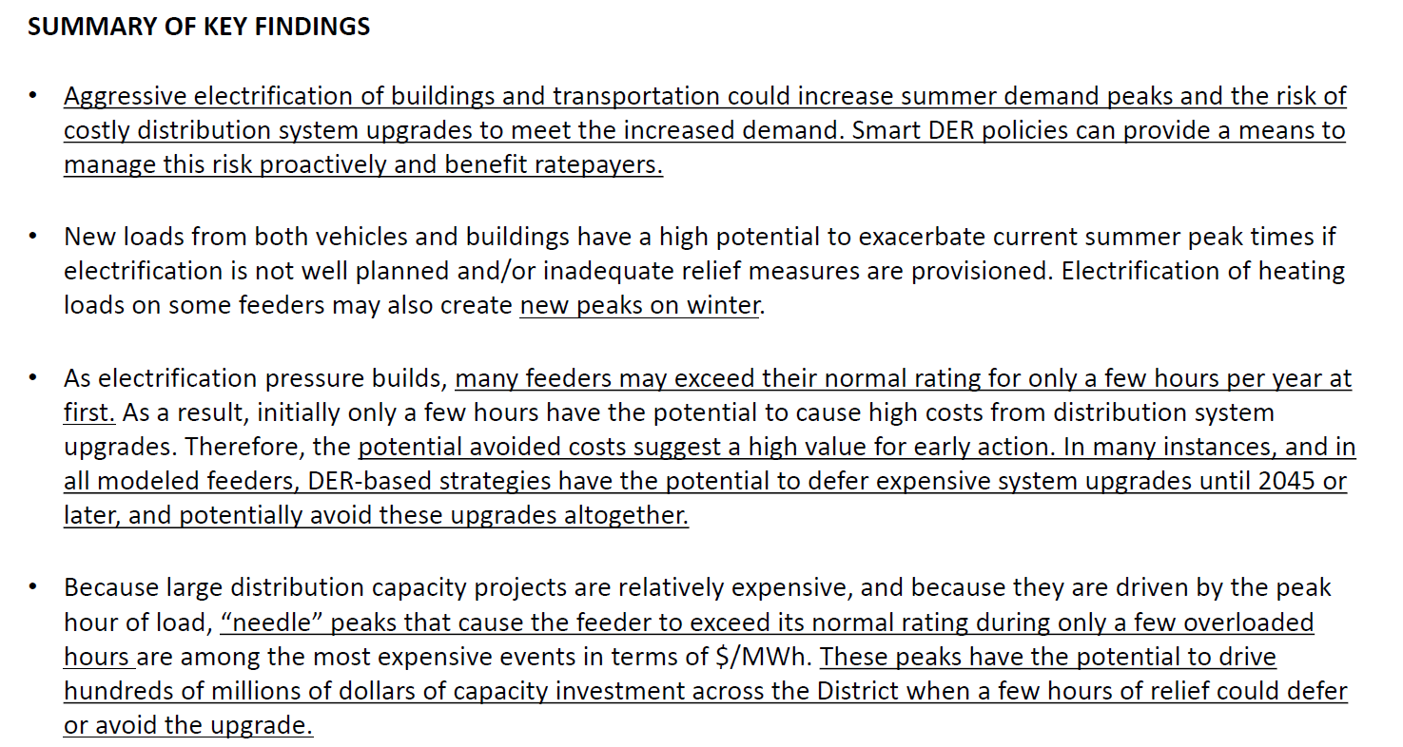
- Nina Dodge highlighted that in California, solar installers are given incentives to have solar panels western facing (rather than southern facing) to capture more of the sun during summer months.
- Mansi Talwar inquired about the difference in designing a southern versus western facing array.
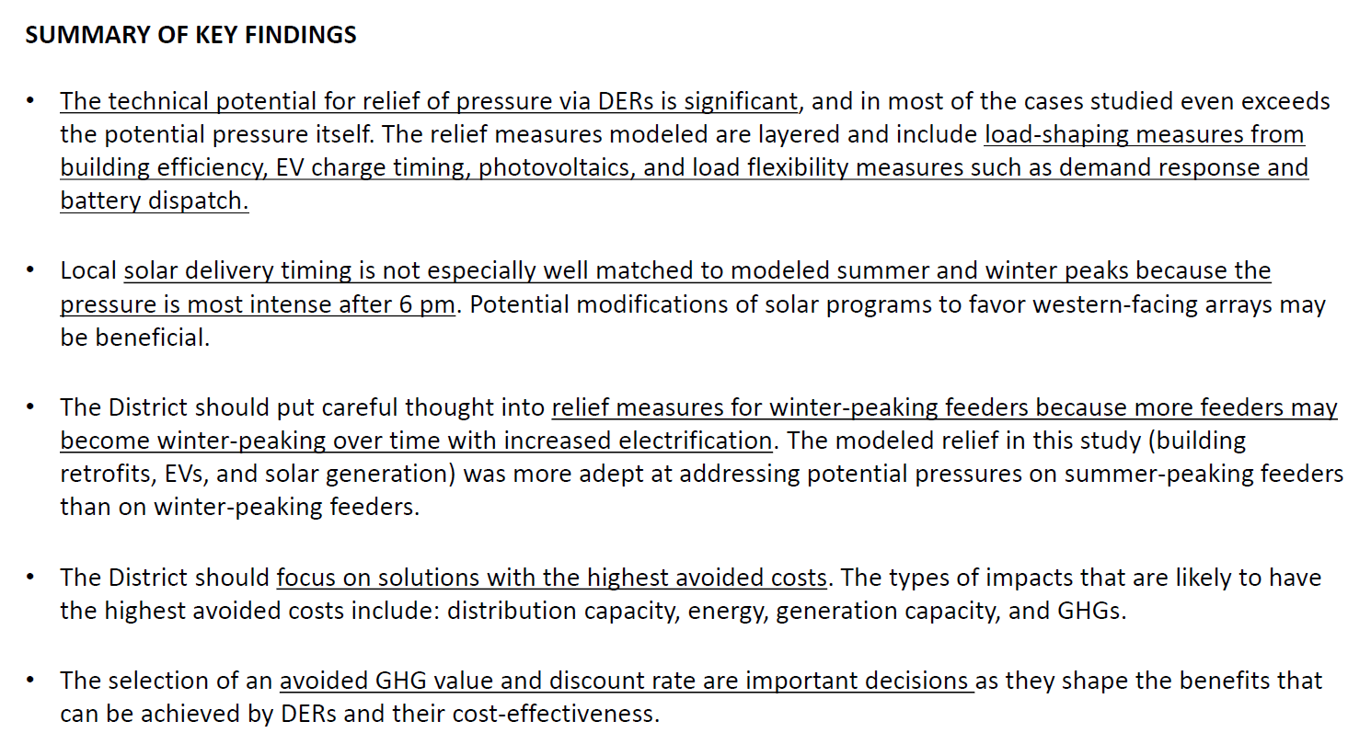
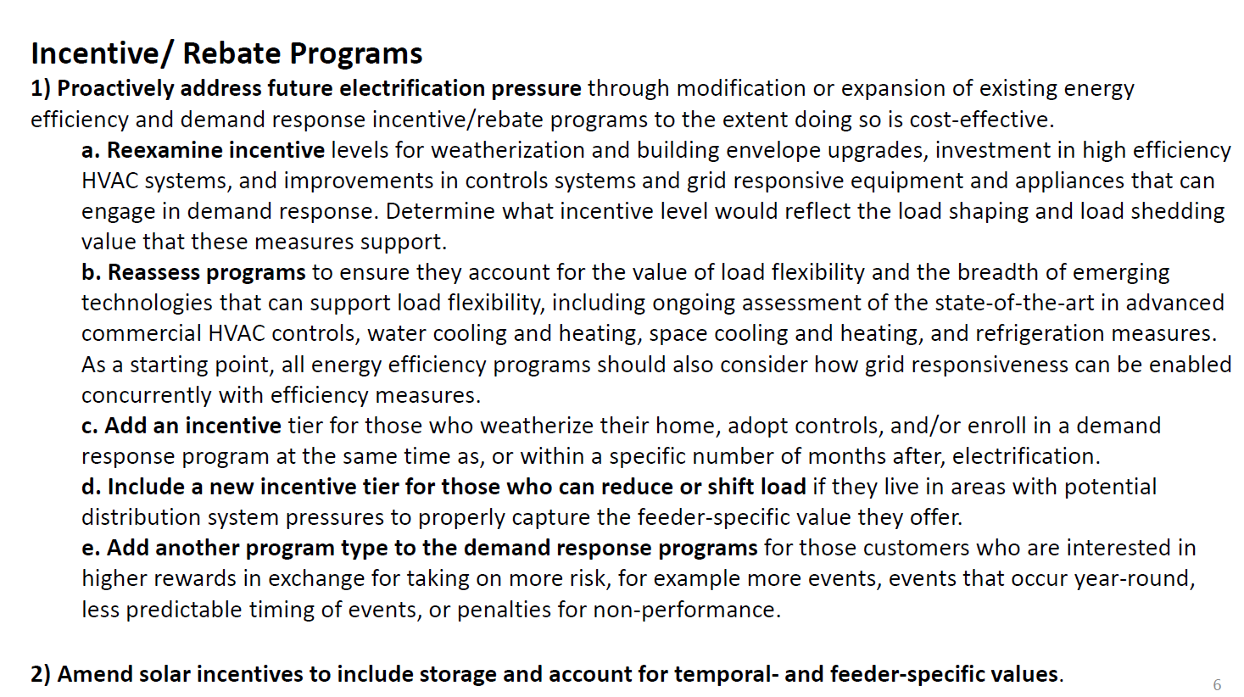
- Nina Dodge pointed out that California incorporated battery storage with time of use rates so the batteries could collect solar energy and then dispatch energy to the grid during peak times.
- Giuls Kunkel added that Met Life is taking advantage of Solar Massachusetts Renewable Target (SMART) rebate program (solar plus storage) and from the owners side, it has been an affective incentive structure to push more solar and storage deployment.
- Jamal Lewis noted that intentional deployment of DERs in conjunction with the Deanwood and River Terrace pilot could provide a valuable impact.
- Jennifer Johnston (DOEE) clarified that the Deanwood and River Terrace neighborhood are focus areas for DCSEU’s Affordable Home Electrification Program.
- Jamal Lewis motioned to develop comments that consider the locational value of distributed energy resources in concert with areas of particular focus to the DCSEU as part of a potential set of comments in response to Synapse’s VDER Study. Nina Dodge seconded the motion. All were in favor except for Eric Jones, who objected. Eric Jones shared that as an AOBA representative, he had concerns with the locational component of the motion.

Formation of Committees
- Nina Dodge motioned to stand up a working group meeting to discuss the Board’s feedback on FC1130 Synapse’s VDER Study and it will be comprised of Board members and DCSEU and DOEE staff members. Vice Chair Dr. Larry Martin offered a friendly amendment to the motion not to preclude other members on the working group who may have expertise on the subject, and seconded the motion. All were in favor, with none opposed.

New Business
- Vice Chair Dr. Larry Martin highlighted the Looking Forward section from the Boards FY22/FY23 report and how he would like the Board to explore more opportunities for DERs, integration of time of use rate management systems, virtual power plants, and microgrids.
  - As the DCSEU secures cost-effective and effective programming in a healthy and fair competition with the utilities for EE, the Board may begin to examine opportunities for pushing into new service areas. Distributed Energy Resources (DER) integration with the utility’s distribution grid offers important opportunities. Aggregated systems management of DER, microgrids and transactional energy sales and purchase between consumers are no longer distant on the horizon but are already demonstrated areas of value creation. The Board may begin exploring opportunities for business models providing a wholistic and integrated process to residents and businesses that could provide turn-key assistance in planning, funding, and installation of comprehensive EE and clean power. As with the bidding of EE into the PJM auction market, the DCSEU may have opportunities to leverage new smart-grid technologies to generate value for both its own programming and for energy customers.
- Vice Chair Dr. Larry Martin and Nina Dodge highlighted the Massachusetts efforts to limit natural gas and repurpose utility infrastructure for ground source heat pumps. Nina noted that it was still in a pilot phase and caution should be exercised in considering it as a national model:
  - The Department of Public Utilities (“Department”) announces a regulatory framework intended to set forth its role and that of the Massachusetts gas local distribution companies (“LDCs”) in helping the Commonwealth achieve its target of net-zero greenhouse gas (“GHG”) emissions by 2050.
- Nina Dodge mentioned the importance of taking advantage of pilots being done elsewhere and getting lessons learned before committing to a new approach.
- Mansi Talwar inquired about the intention of the New Business agenda item.
- Vice Chair Dr. Larry Martin shared that New Business is an opportunity for Board members to discuss items of interest and to explore items for future agendas. Dr. Martin mentioned that his New Business was focused on DERs because the PSC has a $20 million fund in FC1130 (as part of the Exelon merger) to pilot strategies and innovative technologies. One of FC1130 pilots is a virtual power plant. Given DCSEU’s expertise in this space, Dr. Martin asked the group if there was an opportunity to explore the DCSEU’s participation in such a project. .
- Jaleel Shujath highlighted his interest in understanding the full suite of workforce development offerings in the District and inquired whether there was a catalog of green training opportunities. Jaleel also inquired about that status of the Mayor’s goal to provide solar benefits to 100,000 low to moderate income households (Solar for All program).
- Eric Jones shared his expertise in the workforce development arena and cautioned the Board from using buzzwords that do not meet actual reality. One of the problems he has seen, as a former construction lobbyist, is that much of the workforce development has been led by the construction industry over the last two decades. Eric shared that if the Board is going to have workforce development conversations, then those conversations need to be held along with groups such as the Workforce Development Council, Department of Employment Services, DC Youth Apprenticeship Advisory Committee. A lot of that work is already being done and the Board does not want to duplicate efforts already in place. Eric also mentioned a report that will come out next year that explains the work that has already been done in green workforce development.
- Ben Burdick (DCSEU) highlighted that DCSEU’s Train Green program focuses on Certified Business Enterprise (CBE) training for District CBE’s and residents. Ben also mentioned DCSEU’s five-month paid externship which provides on the job training along with certifications.
- Crystal McDonald (DCSEU) shared that DCSEU works closely with DSLBD, DCIA, DOES, and Deputy Mayors office to create opportunities to meet the specific needs to the District.
- Eric Jones mentioned that more than 80% of the local construction industry is represented by one of two groups. Those two groups already have licensed and registered apprenticeship programs (which are licensed by the Department of Labor) through the DC Apprenticeship Council. The Workforce Investment Council coordinates with the Youth Apprenticeship Council to ensure the individuals coming out of those programs qualify and/or meet the standards of pre apprenticeship, apprenticeship, and journeyperson standards. Eric emphasized the importance of coordinating with programs already in place.
- Crystal McDonald (DCSEU) agreed on the importance of coordinating with programs in place and shared she would be happy to continue this conversation.

Board Action Items
- Approval of Meeting Agenda
- Approval of November Minutes
- Approval to develop comments that consider the locational value of distributed energy resources in concert with areas of particular focus to the DCSEU as part of a potential set of comments in response to Synapse’s VDER Study.
- Approval to stand up a working group meeting to discuss the Board’s feedback on FC1130 Synapse’s VDER Study.

Future Agenda Items
- Approval of December Meeting Minutes
- DERs Follow Up Discussion
  - How can the DCSEU enhance DER?
- PSC Pilots
  - What opportunities are there for the DCSEU?
- Workforce Development
  - Is the DCSEU coordinating with the Workforce Investment Council & Youth Apprenticeship Council?
- Discussion on DCSEU Contract Modifications
  - Final action on low-moderate income program evaluation adders
- Legislative Updates

Adjournment
- Vice Chair Dr. Larry Martin adjourned the meeting at 11:40 AM.

Acronyms used during this meeting
- AHRA - Affordable Housing Retrofit Accelerator
- ATO - Authorization to Operate
- BSA - Bill Stabilization Adjustment
- CAEA - Clean and Affordable Energy Act of 2008
- CBE - Certified Business Enterprise
- CEM - Certified Energy Manager
- CREF - Clean Renewable Energy Facility
- DCSEU - District of Columbia Sustainability Energy Utility
- DOB – Department of Buildings
- DOEE - Department of Energy and Environment
- EEDR – Energy Efficiency and Demand Response
- kW - kilowatt
- MOTA – Mayor's Office of Talent and Appointments
- OPC - Office of the People’s Counsel
- PSC - Public Service Commission
- SBCT - Societal Benefit Cost Test
- SETF - Sustainable Energy Trust Fund
- TAG - Technical Advisory Groups
- WGL – Washington Gas Light
Minutes prepared by Jennifer Johnston, DOEE

